

Technical Design Document

Of

<BID # or CR #>: < Robotic Process Automation (RPA) >

Automation Anywhere

|  |  |  |  |  |  |  |  |  |  |  |  |  |  |  |  |  |  |
| --- | --- | --- | --- | --- | --- | --- | --- | --- | --- | --- | --- | --- | --- | --- | --- | --- | --- |
| |  |  |  | | --- | --- | --- | | Author | : | Name of the Author | | Creation date | : | 8 June 2024 | | Last update date | : | 28 July 2024 | | Document reference | : | Document4 | | Document version | : | 1.0 | |  |  |

**Document Control**

| Author | Change Notes | Version | Date |
| --- | --- | --- | --- |
| Islam Nady/Mohamed Amer | Initial Version | 1.0 | 13-Jun-2024 |
| Mohamed Amer | Update Infrastructure section sw list and port list | 1.1 | 28- July-2024 |
|  |  |  |  |
|  |  |  |  |
|  |  |  |  |

**Distribution**

| Copy No. | For | Location |
| --- | --- | --- |
|  |  |  |
|  |  |  |

**References**

| Number | Reference title / Document | Version / Date | Author |
| --- | --- | --- | --- |
|  |  |  |  |
|  |  |  |  |

Table of contents

Table of contents 3

Diagrams Contents 5

Glossary 6

Introduction 7

*Purpose* 7

*Scope* 7

*Business Continuity* 7

*1.**Primary Data Center:* 7

*2.**Secondary Data Center:* 7

*Assumptions* 7

Application Architecture 8

*System Overview* 8

*System Interactions* 9

*1.**… Flow* 10

Infra-structure Architecture 11

*System Production Architecture* 11

*System Disaster Recovery Architecture* 12

*System UAT Architecture* 13

*System SIT Architecture* 13

*System Development Architecture* 13

Capacity Considerations 14

*Disk Storage for X Environment* 16

*Interfaces* 16

*Network Traffic Flow* 16

*DNS Entry* 16

*Network Production Design Diagram* 16

*Network UAT Design Diagram* 16

*Network SIT Design Diagram* 16

*Network Development Design Diagram* 16

*Network Disaster Recovery Design Diagram* 16

System Inventory 17

*Hardware Requirements* 17

ENVIRONMENT 17

Production /UAT /SIT/ DEV /POC 17

SERVER NAME 17

Provided by A&SO if the server is new, if server exist, put the name 17

DESCRIPTION 17

Function of the server 17

IP ADDRESS 17

To be provided by NCD 17

RAM 17

CONNECTION 17

DISK SPACE 17

Should match the data provided in Disk Storage 17

OPERATING SYSTEM 17

CPU 17

SECURITY ZONE 17

To be provided by NSAC (Responsible),Capacity planning (Consultant) 17

*Virtualization* 17

*Software / OS Components* 21

*Licenses* 21

*Tools* 21

Services Requirements 24

*Monitoring* 24

*Hardware Level* 24

*Application /Services Level* 24

*Monitoring for Special Devices* 24

*Backup & Recovery Considerations* 24

*Data Retention* 25

*High Availability* 25

*Service Availability* 25

*Logs* 25

*Start-up Order* 25

Information Security 26

*LDAP (Lightweight Directory Access Protocol)* 26

*Authentication* 26

*Authorization* 26

*PCI* 26

*Port List* 26

*Production Ports List* 26

*VPN* 27

*Shared Folders* 27

*Nat or Pat or Proxy* 27

*User Roles* 27

Client Software Deployment 34

*PC Deployment* 34

*Mobile Deployment* 34

Appendix A: … 35

Diagrams Contents

Application architecture diagram 4

Data Flow diagram 4

Prod diagram 4

DR diagram 4

UAT diagram 4

SIT diagram 4

DEV diagram 4

Glossary

This section lists all terms & acronyms used.

| Short name | Description |
| --- | --- |
| ABIC | Albilad Capital |
| BCM | Business Continuity Management |
| BIA MTPD | Business Impact Analysis Maximum Toleration Period of Downtime |
| DR | Disaster Recovery |
| MQ | Message Queue |
| PCI | Payment Credit Information |
| PROD | Production |
| QoS | Quality of Service |
| RPO | Recovery Point Objective |
| RTC | Recovery Time Capability |
| RTO | Recovery Time Objective |
| SIT | System Integration Testing |
| UAT | Users Acceptance Test |
| VPN | Virtual Private Network |
| RPA | Robotic Process Automation |

Introduction

This document is introducing the Technical Design specifications for adopting Robotic Process Automation (RPA) technology within our company. RPA has emerged as a powerful tool in the financial industry, enabling automation of repetitive and rule-based tasks, enhancing operational efficiency, reducing errors, and improving customer experience. This document will provide a comprehensive overview of the technical aspects involved in the adoption of RPA, including the infrastructure requirements, security, capacity considerations, and deployment strategy.

This document is not intended to address installation and configuration details of the actual implementation.

As is true with any high level design, this document will be updated and refined based on changing requirements.

In recent years, the banking sector has faced increasing pressure to streamline operations and optimize resource utilization. As customer expectations continue to rise, banks must leverage technological advancements to remain competitive. RPA offers a solution by automating manual and time-consuming processes, freeing up valuable human resources to focus on more complex and strategic tasks.

The adoption of RPA technology requires careful planning and consideration of various technical aspects. This document aims to provide a roadmap for the successful implementation of RPA within our bank. It will cover the key components of the RPA ecosystem, including the software platform, development environment, deployment architecture, and security considerations.

By adopting RPA, our bank can achieve numerous benefits, including increased operational efficiency, improved accuracy, reduced costs, enhanced regulatory compliance, and faster processing times. Furthermore, RPA can enable seamless integration between disparate systems, enabling data exchange and process automation across various departments and functions.

*Purpose*

This document describes the procedures and needed technical details for implementing projects with infra-structure. The document is presented for Architecture and Technical Teams discussions to provide common understanding between ABIC various technical department & vendors.

*Scope*

The scope is to implement processes of RPA system from “Automation Anywhere” company. The process follows Bank Albilad and Albilad Capital standards.

The following to be taken in consideration:

1. Technology Support multi-tenant: To make sure we can have logical segregation between BAB & ABIC.
2. Software robots all require a PC, a user account(s), and access to an application(s).
3. Version control is required.

*Business Continuity*

<This section is filled after discussion between BCM & Business to understand / identify the criticality of the system>

Critical level: <Please fill>

Failover required: <Yes/No>

BCM comments: <Fill if required>

BIA MTPD: <Please fill in mins, hours>

### *Primary Data Center:*

* 1. RTO: <Please fill in mins, hours>
  2. RPO: <Please fill>

### *Secondary Data Center:*

* 1. RTO: <Please fill in mins, hours>
  2. RPO: <Please fill>
  3. RTC: <Please fill in mins, hours>

*Assumptions*

* There will be a production environment and SIT/UAT environments.

Application Architecture

*System Overview*

RPA system consists of several components that work together to automate business processes. Here are the main functions and components of an RPA system.

### *Components*

Automation Anywhere platform is deployed using a distributed architecture. Centralized management is accomplished via a web-based server, called the Control Room, to manage all development and execution of the digital workforce. The Control Room is connected to Bot Creators and Bot Runners. Bot Creators are development systems used for authoring and tailoring of automations. Bot Runners execute the automation; they are run-time systems installed on machines. Bot Runners can be deployed on desktops, on virtual machines in data centers or cloud.

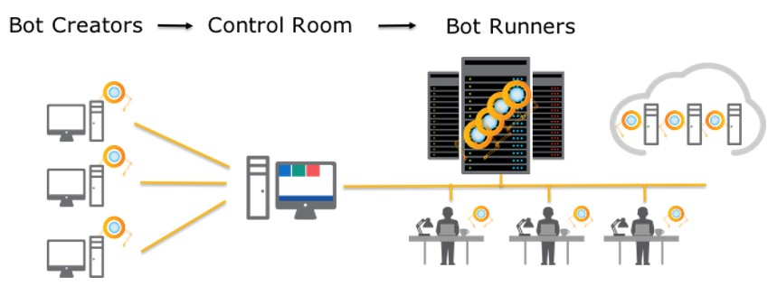

Application architecture diagram

### *Reference Architecture*

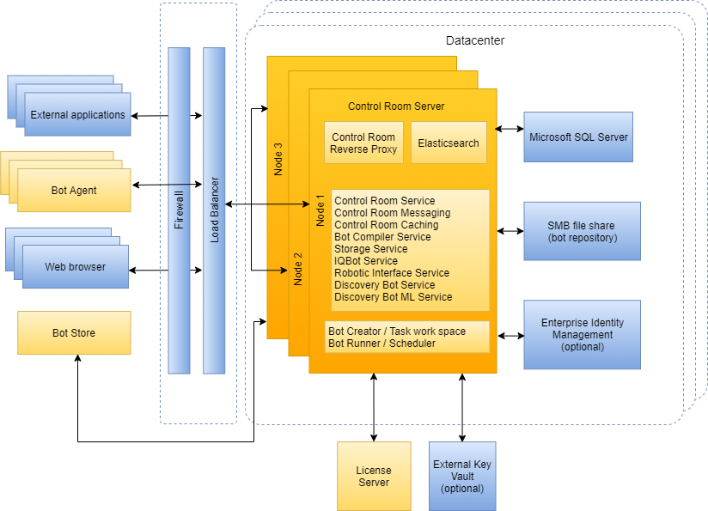

Automation Anywhere RPA Platform Reference Architecture

### *RPA Process Architecture*

Automation Anywhere RPA Platform Reference Architecture

*System Interactions*

RPA bot agents will mimic business users’ daily tasks interactions through different business systems to achieve the same target business capability.

### *Automation Flow*

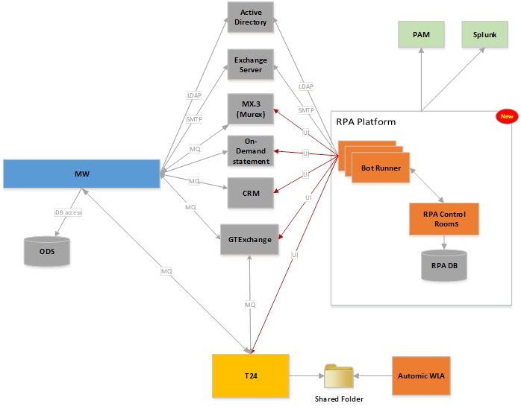

Data Flow diagram

### *Selected Processes for Automated*

Multiple business flows to be automated using RPA bots agents as per CR 649941 scope.

|  |  |  |  |  |
| --- | --- | --- | --- | --- |
| # | Process Name | Business Owner | CR | Digital Worker |
| 1 | Nafith |  |  | Bot Runner 1 |
| 2 | Subscription/Redemption. |  |  | Bot Runner 2 |
| 3 | IBKR Onboarding . |  |  | Bot Runner 2 |
| 4 | Account Opening – Local Brokerage. |  |  | Bot Runner 3 |
| 5 | KYC Update. |  |  | Bot Runner 3 |

Infra-structure Architecture

*System Production Architecture*

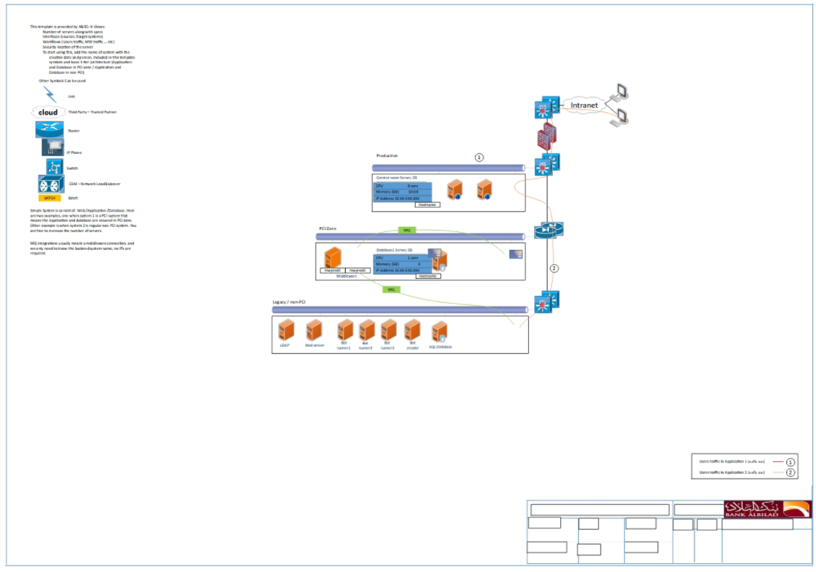

Prod diagram

*System Disaster Recovery Architecture*

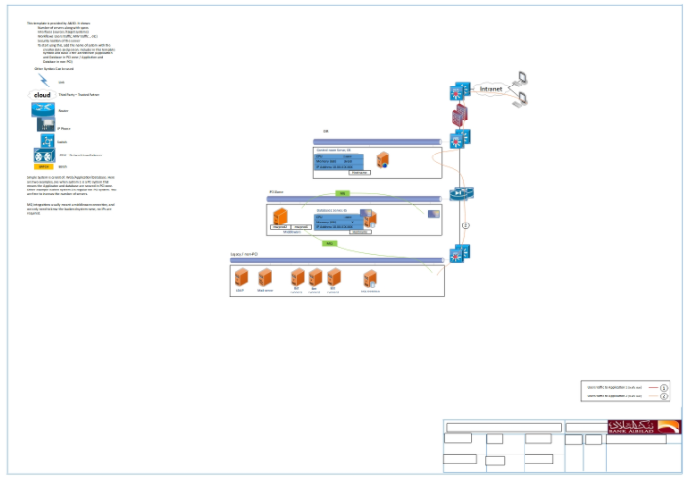

DR diagram

*System UAT Architecture*

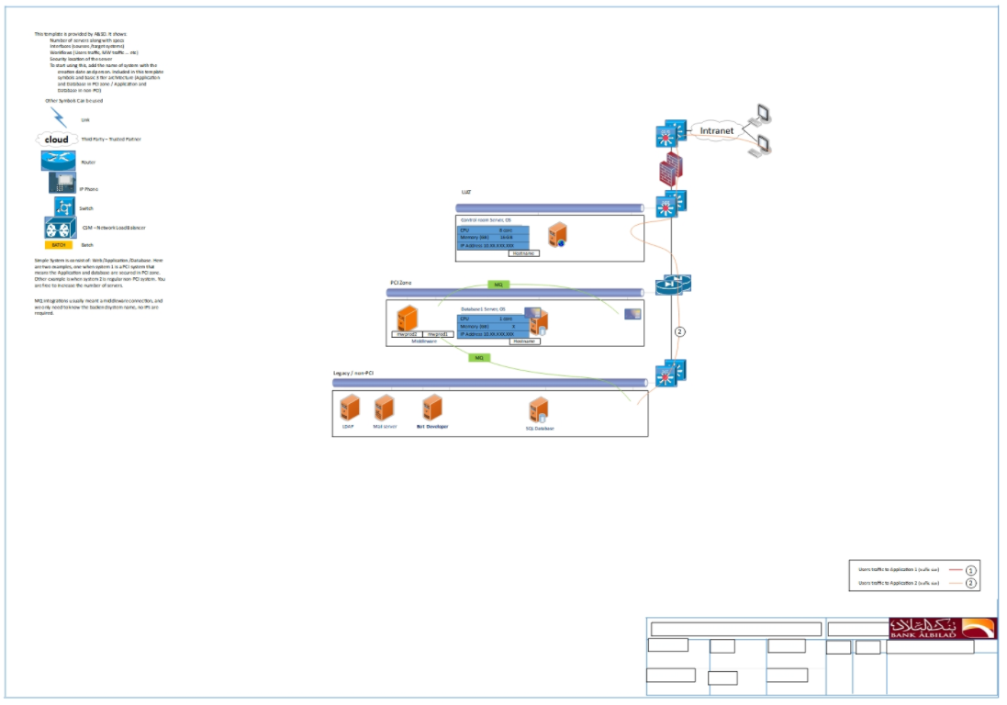

UAT diagram

*System SIT Architecture*

SIT diagram

*System Development Architecture*

DEV diagram

Capacity Considerations

For Prod setup, It is required below list of servers VMs with the mentioned storage specifications and 1 GBE for network speed.

*Disk Storage for Production Environment*

| Name | Size | Temporary / Permanent | backup |
| --- | --- | --- | --- |
| Control Room – 2 VM | 60 (C:\ Drive)  500 (D:\ Drive) | Permanent |  |
| Database – minimum 1 VM (C:\ Drive) , preferable clustered for high availability | 60 (C:\ Drive)  200 (D:\ Drive) | Permanent |  |
| Bot Runner Agent – 3 VM (C:\ Drive) | 50 | Permanent |  |
| Bot Runner Agent – 1 physical machine (C:\ Drive) | 50 | Permanent |  |

*Interfaces*

Interfaces are listed in the Network Architecture above.

| Source Server | Destination Server | Protocol (MQ, TCP, SFTP, ODBC, JDBC, HTTPS, …) / Port |
| --- | --- | --- |

|  |  |  |  |  |  |  |  |  |  |  |  |  |  |  |  |  |  |
| --- | --- | --- | --- | --- | --- | --- | --- | --- | --- | --- | --- | --- | --- | --- | --- | --- | --- |
| Control Room | Active Directory | |  |  |  | | --- | --- | --- | | LDAP | 389 (TCP) | User authentication | | LDAP SSL | 636 (TCP) | User authentication | | LDAP global controller | 3268 (TCP) | User authentication | | LDAP global controller SSL | 3269 (TCP) | User authentication | | Kerberos | 88 (TCP and UDP) | User authentication | |
| Bot runner | Active Directory |
| Bot runner | Control Room | HTTPS/443 - HTTP&HTTPS/8080 - HTTP/80 |
| Bot Creator | Control Room | HTTPS/443 - HTTP8080 |
| Control Room | Bot runner | HTTPS/443 - HTTP8080 |
| Control Room | Bot Creator | HTTPS/443 - HTTP8080 |
| Control Room | Database Server | SQL Server Port Number-default 1433 |
| Bot Runner | Target processes applications servers | Applications ports |
| Bot Creator | Target processes applications servers | Applications ports |
| Bot Runner | Database Server | SQL Server Port Number-default 1433 |
| Bot Creator | Database Server | SQL Server Port Number-default 1433 |

*Network Traffic Flow*

|  |  |  |  |  |  |  |
| --- | --- | --- | --- | --- | --- | --- |
| Source | target | Run | Traffic size (KB/MB/GB) | Schedule Time | QoS | Comments |
| Control Room | Database Server | Online | [1 GbE](https://docs.automationanywhere.com/bundle/enterprise-v2019/page/enterprise-cloud/topics/deployment-planning/on-prem-install/cloud-requirements-server-hardware.html) | 24/7 | High |  |
| Control Room | Bot runner | Online | [1 GbE](https://docs.automationanywhere.com/bundle/enterprise-v2019/page/enterprise-cloud/topics/deployment-planning/on-prem-install/cloud-requirements-server-hardware.html) | 24/7 | High |  |
| Bot runner | Control Room | Online | [1 GbE](https://docs.automationanywhere.com/bundle/enterprise-v2019/page/enterprise-cloud/topics/deployment-planning/on-prem-install/cloud-requirements-server-hardware.html) | 24/7 | High |  |

* Traffic schedule time (e.g. online during business hours or 24/7, batch every day at 7 p.m.).
* Repeat the table per environment.
* Sequential Number that is mentioned in the Diagram.
* Quality of Service (QoS) could be (Law, High, Normal).

*DNS Entry*

No software use static IP will be installed. IP change can be done easily at any time.

<The above statement is confirming that during installation a hostname can be used instead of IP address. This should not be erased unless it is not true.>

|  |  |  |  |
| --- | --- | --- | --- |
| Classification | FQDN* | IP Address | Comments |
| External DNS |  |  |  |
| Internal DNS |  |  |  |
|  |  |  |  |
|  |  |  |  |

* FQDN Fully Qualified Domain Name

*Network Production Design Diagram*

The below diagram is the network architecture as provided by vendor.

Network Architecture

This is reference network architecture for On-premises deployments; however, the following points will be taken into account since the deployment is going to be a Prod

* Control Room Data Tier:
* Database will be MSSQL
* Shared file repository will reside on the same Control room, and it is not required to be on separate server
* Version control will not be needed.
* Real time data service will not be needed

….































*Network UAT Design Diagram*

This is provided by NCD after the document is approved for distribution.

*Network SIT Design Diagram*

This is provided by NCD after the document is approved for distribution.

*Network Development Design Diagram*

This is provided by NCD after the document is approved for distribution.

*Network Disaster Recovery Design Diagram*

This is provided by NCD after the document is approved for distribution.

System Inventory

*Hardware Requirements*

|  |  |
| --- | --- |
| ENVIRONMENT | Production – Control room1 |
| SERVER NAME | Provided by A&SO if the server is new, if server exist, put the name |
| DESCRIPTION | Control Room |
| IP ADDRESS | To be provided by NCD |
| RAM | 16 GB |
| CONNECTION |  |
| DISK SPACE | 60 C: Drive  500 D: Drive |
| OPERATING SYSTEM | 2016 , 2019 or 2022 Datacenter |
| CPU | 8 Cores |
| SECURITY ZONE | To be provided by SOC |



|  |  |
| --- | --- |
| ENVIRONMENT | Production – Control room2 |
| SERVER NAME | Provided by A&SO if the server is new, if server exist, put the name |
| DESCRIPTION | Control Room |
| IP ADDRESS | To be provided by NCD |
| RAM | 16 GB |
| CONNECTION |  |
| DISK SPACE | 60 C: Drive  500 D: Drive |
| OPERATING SYSTEM | 2016 , 2019 or 2022 Datacenter |
| CPU | 8 Cores |
| SECURITY ZONE | To be provided by SOC |

*Note: Control room requires SQL database server, below is the specs for single node of SQL database server, however for full high availability , high available SQL servers with multiple nodes and storage should be provided by BAB database archetict team.*

|  |  |
| --- | --- |
| ENVIRONMENT | Production – Database |
| SERVER NAME | Provided by A&SO if the server is new, if server exist, put the name |
| DESCRIPTION | SQL Database |
| IP ADDRESS | To be provided by NCD |
| RAM | 24 GB |
| CONNECTION |  |
| DISK SPACE | 60 C: Drive  500 D: Drive |
| OPERATING SYSTEM | 2016 , 2019 or 2022 Datacenter |
| CPU | 8 Cores |
| SECURITY ZONE | To be provided by SOC |

|  |  |
| --- | --- |
| ENVIRONMENT | UAT – Control room |
| SERVER NAME | Provided by A&SO if the server is new, if server exist, put the name |
| DESCRIPTION | Control Room |
| IP ADDRESS | To be provided by NCD |
| RAM | 16 GB |
| CONNECTION |  |
| DISK SPACE | 60 C: Drive  500 D: Drive |
| OPERATING SYSTEM | 2016 , 2019 or 2022 Datacenter |
| CPU | 8 Cores |
| SECURITY ZONE | To be provided by SOC |

|  |  |
| --- | --- |
| ENVIRONMENT | UAT – Database |
| SERVER NAME | Provided by A&SO if the server is new, if server exist, put the name |
| DESCRIPTION | SQL Database |
| IP ADDRESS | To be provided by NCD |
| RAM | 24 GB |
| CONNECTION |  |
| DISK SPACE | 60 C: Drive  500 D: Drive |
| OPERATING SYSTEM | 2016 , 2019 or 2022 Datacenter |
| CPU | 8 Cores |
| SECURITY ZONE | To be provided by SOC |

|  |  |
| --- | --- |
| ENVIRONMENT | DR – Control room |
| SERVER NAME | Provided by A&SO if the server is new, if server exist, put the name |
| DESCRIPTION | Control Room |
| IP ADDRESS | To be provided by NCD |
| RAM | 16 GB |
| CONNECTION |  |
| DISK SPACE | 60 C: Drive  500 D: Drive |
| OPERATING SYSTEM | 2016 , 2019 or 2022 Datacenter |
| CPU | 8 Cores |
| SECURITY ZONE | To be provided by SOC |

*Virtualization*

The system is using virtual server(s). Virtual machines: A virtual machine is a collection of different solutions that virtualized below the operating system, whereby a thin layer of software enables a customer to run multiple identical or different operating systems and applications in isolation from each other. Like containers, a "virtual machine" can isolate faults so that the surrounding VMs can continue to run.

|  |  |
| --- | --- |
| ENVIRONMENT | Production Bot Agent – 3 VM (virtual PC) |
| SERVER NAME | Provided by A&SO if the server is new, if server exist, put the name |
| DESCRIPTION | Bot Runner |
| IP ADDRESS | To be provided by NCD |
| RAM | 12 |
| CONNECTION |  |
| DISK SPACE | 50 |
| OPERATING SYSTEM | Windows 11 OR Windows 10 or 2016 , 2019  (request to Involve client systems team to install the required applications) |
| CPU | 4 cores |
| SECURITY ZONE | To be provided by SOC |

|  |  |
| --- | --- |
| ENVIRONMENT | DR Bot Agent – 3 VM (virtual PC) |
| SERVER NAME | Provided by A&SO if the server is new, if server exist, put the name |
| DESCRIPTION | Bot Runner |
| IP ADDRESS | To be provided by NCD |
| RAM | 12 |
| CONNECTION |  |
| DISK SPACE | 50 |
| OPERATING SYSTEM | Windows 11 OR Windows 10 or 2016 , 2019  (request to Involve client systems team to install the required applications) |
| CPU | 4 cores |
| SECURITY ZONE | To be provided by SOC |

*Physical PC*

|  |  |
| --- | --- |
| ENVIRONMENT | Production Bot Agent – 1 (Physical PC) |
| SERVER NAME | Provided by A&SO if the server is new, if server exist, put the name |
| DESCRIPTION | Bot Runner |
| IP ADDRESS | To be provided by NCD |
| RAM | 12 |
| CONNECTION |  |
| DISK SPACE | 50 |
| OPERATING SYSTEM | Windows 11 OR Windows 10  (request to Involve client systems team to install the required applications) |
| CPU | 4 cores |
| SECURITY ZONE | To be provided by SOC |

*Physical PC*

|  |  |
| --- | --- |
| ENVIRONMENT | UAT Bot Agent – 1 (Physical PC) |
| SERVER NAME | Provided by A&SO if the server is new, if server exist, put the name |
| DESCRIPTION | Bot Runner |
| IP ADDRESS | To be provided by NCD |
| RAM | 12 |
| CONNECTION |  |
| DISK SPACE | 50 |
| OPERATING SYSTEM | Windows 11 OR Windows 10  (request to Involve client systems team to install the required applications) |
| CPU | 4 cores |
| SECURITY ZONE | To be provided by SOC |

*Physical PC (this might be required in DR for nafith process for manual processing nafith login)*

|  |  |
| --- | --- |
| ENVIRONMENT | DR Bot Agent – 1 (Physical PC) |
| SERVER NAME | Provided by A&SO if the server is new, if server exist, put the name |
| DESCRIPTION | Bot Runner |
| IP ADDRESS | To be provided by NCD |
| RAM | 12 |
| CONNECTION |  |
| DISK SPACE | 50 |
| OPERATING SYSTEM | Windows 11 OR Windows 10  (request to Involve client systems team to install the required applications) |
| CPU | 4 cores |
| SECURITY ZONE | To be provided by SOC |

*Software / OS Components*

Following software/OS components are required:

|  |  |
| --- | --- |
| SERVER NAME | Control Room |
| SOFTWARE LIST | * Microsoft Edge, * Chrome, * Bot Agent * SQL Management Studio |

|  |  |
| --- | --- |
| SERVER NAME | Bot Runners / Bot Creators devices |
| SOFTWARE LIST | * Microsoft Office 2016/2019 including outlook,excel,word,access * Microsoft Edge. * Edge Extension “Automation360Extension” will be installed during device configuration, * Google Chrome * Chrome Extension “Automation360Extension” will be installed during device configuration, * ”Bot Agent“ will be installed during device configuration,   Microsoft Access Database Engine 2010 Redistributable <https://www.microsoft.com/en-us/download/details.aspx?id=13255>   * AT Application * ffmpeg package from (<https://www.gyan.dev/ffmpeg/builds/>) * Download open ai - whisper package on the machines. * Python.exe SW * Python packages indices files from [PyPI · The Python Package Index](https://pypi.org/) |



*Licenses*

List quantity of license you required. License should be detailed specifying products and determine if it is server based /named users /unlimited site /concurrent users. No cost is required to mention here. (If the license is available mention it is available).

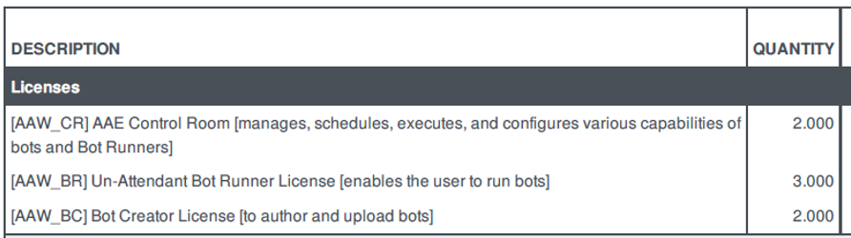

* Bot creators and bot runners license are named license
* License type: annual subscription

*Tools*

For ‘build from scratch’ projects and for Package Implementation projects describe the tools used in developing the design.

For ‘support service’ projects, describe the tools needed to support the design.

* Edge Extension “Automation360Extension”.
* Automation Anywhere Bot Agent

**Processes Automation requirements**

# Automation Prerequisites Nafith process

This section is to consolidate all technical prerequisites that are mandatory to start the automation.

|  |  |
| --- | --- |
| Item | Ownership |
| BOT agent readiness with all process applications as below   * Windows ID. * Email ID. * AT (User and password). * CMA Nafith (Username, password, email address to receive OTP from nafith portal). * SQL account with a permission to create a database and tables – read/write on the custom operation DB * Access to shared folder. * Internet access * install ffmpeg , package from  (<https://www.gyan.dev/ffmpeg/builds/>) * Download open ai - whisper package on the machines. * Python.exe SW * Python packages indices files from [PyPI · The Python Package Index](https://pypi.org/) * Speech to text model | Albilad Capital |
| The email address should be for the windows ID that will be assigned to nafith process | Albilad Capital |

# Automation Prerequisites opening accounts – local brokerage

This section is to consolidate all technical prerequisites that are mandatory to start the automation.

|  |  |
| --- | --- |
| Item | Ownership |
| BOT agent readiness with all process applications as below   * Windows ID * Email ID * AT (User and password) * World check (User and password) * SQL account with a permission to create a database and tables – read/write * Access to shared folder * Internet access * Test data to cover both the happy and unhappy scenarios.. | Albilad Capital |

# Automation Prerequisites KYC Update

This section is to consolidate all technical prerequisites that are mandatory to start the automation.

|  |  |
| --- | --- |
| Item | Ownership |
| BOT agent readiness with all process applications as below   * Windows ID * Email ID * AT (User and password) * SQL account with a permission to create a database and tables – read/write * Access to shared folder * Test data to cover both the happy and unhappy scenarios. | Albilad Capital |

# Automation Prerequisites subscription and redemption

This section is to consolidate all technical prerequisites that are mandatory to start the automation.

|  |  |
| --- | --- |
| Item | Ownership |
| BOT agent readiness with all process applications as below   * Windows ID * Email ID * T24 maker account. * T24 checker account. * SQL account with a permission to create a database and tables – read/write * Access to shared folder * Test data to cover both the happy and unhappy scenarios. | Albilad Capital |

# Automation Prerequisites – IBKR Onboarding

This section is to consolidate all technical prerequisites that are mandatory to start the automation.

|  |  |
| --- | --- |
| Item | Ownership |
| BOT agent readiness with all process applications as below   * Windows ID * Email ID * Client Account (User and password) * T24 (User and password) * AT (User and password) * SQL account with a permission to create a database and tables – read/write * Access to shared folder * Test data to cover both the happy and unhappy scenarios. | Albilad Capital |

Services Requirements

*Monitoring*

### *Hardware Level*

List all the servers to be monitored and what to be monitored (CPU, Memory, Network, I/O …). Specify the people to be contacted in case of alarm.

* Control room servers (CPU, Memory, Network, Disk space)

### *Application /Services Level*

List all the servers to be monitored and what to be monitored (CPU, Memory, Network, I/O …). Specify the people to be contacted in case of alarm.

### *Monitoring for Special Devices*

Equipments like Link Protector, printers or any device other than servers.

*Backup & Recovery Considerations*

Provide the backup details IP address, host name, OS platform for the server, there is a need to know that back up have three kinds for file systems:

* Daily – the backup type incremental – the data retention is one week
* Weekly – the backup type is full – the data retention is four weeks
* Monthly – the backup type is full – the data retention is 3 months
* Type of backup:

o Image Backup: Weekly full system image backup

o DB Backup: Daily incremental, Weekly and Monthly full backups

**Database Backup:**

* It's crucial to align the database backup frequency and type with the operational requirements of the Automation Anywhere environment. For high-transaction environments, consider more frequent incremental backups.

**Recovery Considerations:**

* Allocated Space for Recovered Data: Ensure at least 1.5 TB of space is available for recovery processes, allowing for the restoration of the most significant full backup and additional space for recovery operations.

|  |  |
| --- | --- |
| Client name |  |
| Contact information |  |
| Operating System | Windows Server 2022 |
| Database Type | Microsoft SQL Server |
| Total Storage available | 500 GB (This should be adjusted based on the scale of your Automation Anywhere deployment and expected data growth.) |
| File system names | D:\AutomationData |
| Total storage used (GB) | 500 GB |
| Total data changed per backup (GB) | 50 GB (This is an estimate; actual values will vary based on operation intensity.) |
| Total GB to be backed up | 1.0 TB (Considering some data may not require backup, like temporary files.) |
| Number of backup versions to be kept | Daily for 7 days, Weekly for 4 weeks, Monthly for 12 months |
| Backup file retention period | * Daily: Incremental – 1 week * Weekly: Full – 4 weeks * Monthly: Full – 12 months |
| Backup window times | It is up to BAB backup policies – However it is recommended to perform the backup outside business working hours  Daily at 1:00 AM for Incremental, Sunday at 2:00 AM for Full |
| Average GB copied per archive | 200 GB (This will depend on the change rate of data.) |
| Number of files archived | Varies based on data and operations |
| Number of archives kept | Corresponds to the retention policy |
| Archive frequency | Daily for incremental, Weekly and Monthly for full backups |
| Archive windows times | Immediately following the respective backup window |

Note: This example is based on general best practices and should be adapted to fit the specific needs and operational realities of your Automation Anywhere deployment. Always consider the criticality of the data, the acceptable recovery time objectives (RTO), and recovery point objectives (RPO) when designing your backup and recovery strategy.



*Data Retention*

In RPA (Robotic Process Automation) technology, data retention refers to the practice of storing and keeping data for a specific period of time, by definition RPA will not store business data in RPA backend database, but the bot agents deals will critical business data through different systems, different data sources and files like (Microsoft excel sheets, Microsoft Access database, RDBMS databases, …etc), and handling the data through each data source will be part of the automation implementation based on business requirements as the bot will be exactly like the human worker, data retention/deletion will be part of the business scenario, and monitored by human business operation.

*High Availability*

If your system is load balanced, specify how this is done, is it using Hardware such as CSM, or using Software like Vertias, MS Cluster, HACMP, WebSphere cluster, and so on.

Be aware If you run on virtual environment, you are already high available.

RPA control room relies on Network load balancer in high availability deployment mode

As a best practice, ensure the load balancer:

* (Required) Supports WebSocket protocol
* (Preferred) Uses round-robin host selection and is not configured to use persistent (sticky) sessions.
* (Preferred) Has idle timeout set to 120 seconds.

The timeout value depends on the process time of various actions in the Control Room such as the time required to check in and check out bots, import bots, and download bot dependencies.

*Service Availability*

Is the system required to be available 24/7; the following questions are to be answered.

* In case of Application upgrade will this require a down time? Yes
* In case of hardware OS upgrade will this affect the services availability. Yes

*Logs*

Application logs are generated on path:

* Bot Runner/Bot Creator: (C:\ProgramData\AutomationAnywhere\BotRunner\Logs).
* Control Room (C:\ProgramData\AutomationAnywhere\Logs).

*Start-up Order*

The standard sequence of starting up the servers is:

1. Database server first.
2. Control room.
3. Bot Runner.

Information Security

This section is highly important; assure you cover all the security aspects of the system/project.

*LDAP (Lightweight Directory Access Protocol)*

### *Authentication*

Any Individual accessing the application or any server will use their unique active directory identifier. This includes system administrators, users and application administrators.

Any services account (account doesn’t belong to individual) will be managed by ISSD. The Password change in a regular base and it is according to ISSD Security Procedures.

To increase the level of security and to facilitate the user accounts management. The system is integrated with LDAP/Domain Controllers.

Kerberos Authentication is used.

Windows Native Authentication is used.

Please edit this paragraph to fit your system security.

### *Authorization*

The authorization is done using Active Directory Groups, or it could be done locally by the system/software.

*PCI*

PCI Compliance is not required because this system doesn’t contain, display, forward or store any credit card information on any of the system servers.

The above statement is not to be erased unless it is not true, to help you identified if you need to be PCI compliance; you have to answer at least one YES to one of the following questions

* Does the system receive full card numbers (Y/N)? No
* Does the system send full card numbers (Y/N)? No
* Does the system store full card numbers (Y/N)? No
* Does the system display full card numbers (Y/N)? No
* Does the system process full card numbers (Y/N)? No

If your answer was “No” to all of the above questions, then your system is out of the PCI-DSS project scope.

If your answer was “Yes” to one, you are required to have the following:

PCI Required Agents / Required OS and DB Hardening

* Tripwire OS Agent for Platform
* Tripwire Oracle on SUN DB Connector /SQL Connector
* PCI Hardening for OS
* PCI Hardening for Oracle DB /SQL

*Port List*

List all the ports to be opened, this includes firewall ports and any communication ports such as application to database traffic.

### *Production Ports List*

| Source (Computer Name/IP) | Destination (Computer name/IP) | TCP / UDP / Both | Port number |
| --- | --- | --- | --- |
| Control Room | Active Directory | |  |  |  | | --- | --- | --- | | LDAP | 389 (TCP) | User authentication | | LDAP SSL | 636 (TCP) | User authentication | | LDAP global controller | 3268 (TCP) | User authentication | | LDAP global controller SSL | 3269 (TCP) | User authentication | | Kerberos | 88 (TCP and UDP) | User authentication | | |
| Bot runner | Active Directory |
| Bot runner | Control Room | Both | 8080/443 |
| Bot Creator | Control Room | Both | 8080/443 |
| Control Room | Bot runner | Both | 8080/443 |
| Control Room | Bot Creator | Both | 8080/443 |
| Control Room | Database Server | TCP | SQL Server Port Number |
| Control Room | Shared folder | UDP | 445 |
| Bot runner | Shared folder | UDP | 445 |
| Bot creator | Shared folder | UDP | 445 |
| Control room | Splunk IP |  |  |
| Control room | Email server | SMTP |  |
| Bot creators and runners machines | Database Server | TCP | SQL Server Port Number |
| Bot creators and runners machines | AT servers | TCP |  |
| Bot creators and runners machines | T24 | TCP |  |
| Bot creators and runners machines | Client Account | TCP |  |



*VPN*

If this is needed, a VPN client should be mentioned in software list.

*Shared Folders*

List the shared folders path; be aware that the access of the shared folders is controlled by ISSD dept.

* A shared folder is required for control room high availability deployment mode, we can start with 60 GB then increase it later as we go.

*Nat or Pat or Proxy*

Is there any connection with a public network (internet) that required for a NAT or PAT or Proxy? No

*User Roles*

| Users | Roles | Active Directory Group Name | Env |
| --- | --- | --- | --- |
| Bot Developer 1 (C/EXXXXXX) |  |  | UAT |
| Bot Developer 2 (C/EXXXXXX) |  |  | PRD |
| Bot Admin (C/EXXXXXX) |  |  | UAT/PRD |
| Bot Runner 1 (C/EXXXXXX) |  | <To be determined after full analysis for the use cases> | PRD |
| Bot Runner 2 C/EXXXXXX) |  | <To be determined after full analysis for the use cases> | PRD |
| Bot Runner 3 C/EXXXXXX) |  | <To be determined after full analysis for the use cases> | PRD |

This table contains the profiles of all users in the application. It is required to be filled for security team so they identify the needed groups in active directory.

*RPA Security Controls*

Below security controls need to be addressed during solution implementation:

1. Centralize the RPA access management into an IDM solution in coordination with the SAC team, in accordance with the SAMA Cybersecurity Framework.
   1. RPA platform **as a software**, Service account to be created and added to the Security OU (Login to server or system to be restricted; these service accounts should be used only to start/stop systems services and to connect network resources functionality only), and Service account passwords are to be managed by the SAC team.
   2. RPA platform **as a digital workers,** a new Security Group = “Digital Workers” to be created in ADS server with set specific security policy (e.g. password requirements will be different than normal employees, ..etc) and this security group to be added to a new OU = “Digital Workers”, and for a Digital worker to access a new business application, it will require to use same request which is used for human access through e-services (need to check the changes on Skelta & ServiceNow).
2. Create unique accounts and implement access control in coordination with Information Security. The service account needs to be approved by the information security account.
3. Critical and Admin account needs to be Integrated with PAM (agreed with IS team this control only applicable on production environment).
4. Storge authentication: ensure adherence to BAB Information security policy and password standard.
5. Data at Rest: SQL, Oracle, Database Implement TDE security control.

Assessment is done with the RPA vendor as belowfor both Automation 360 and the custom operation database that will be used for the automated processes as below

|  |  |
| --- | --- |
| Assessment Question | Vendor Answer |
| 1. What is the nature of the data stored in the database ? | A.The information stored in the Automation 360 (A360) database includes a variety of data types that are essential for the functioning and management of the Automation 360 platform. here are some specific types of information that are typically stored in the A360 database:   1. User Details: This includes anonymized user information which could encompass user IDs, roles, and possibly their interaction with the platform. This data helps in managing user access and permissions, as well as in analyzing how users interact with the system. 2. User Navigation Workflows: Detailed logs of menus accessed by users, clicks, and possibly the sequence of actions performed within the Automation 360 platform. This data is crucial for understanding user behavior, optimizing the user interface, and troubleshooting issues. 3. Bot Information: Details about the bots created and managed within the platform, including their code, execution logs, schedules, and performance metrics. This information is key to bot lifecycle management, from development through to monitoring and optimization. 4. Execution Logs: Records of bot executions, including timestamps, outcomes (success/failure), and possibly error messages or codes. These logs are vital for operational monitoring, debugging, and compliance auditing. 5. Configuration Settings: Settings and preferences configured within the platform, which could include security settings, feature toggles, and integration configurations. This ensures the platform operates according to the specific needs and policies of the organization. 6. Security and Access Control Information: Details related to the authentication and authorization mechanisms, including user access logs, permission settings, and security policies applied. This is critical for maintaining the security and integrity of the platform.   B. The information stored in the custom operation database includes a variety of data types that are essential for executing, processing, monitoring and management of the Automation for each process in the project scope. here are some specific types of information that are typically stored in the custom automated processes database:   * 1. Request details: as received from business users or from external parties , bot will store the mandatory information for the request that will be executed.   2. Request execution status: this acts like execution tracking in order to Identify the status for each request during bot execution.   3. Automation benefits or ROI: we include all ROI parameters that can help in measuring the automation benefits like number of processed requests, saved hours or money and number of automated processes.   4. Exception errors: for monitoring hypercare and tuning purpose for production processes in order to help in increase the bot performance. |
| 1. Is there any information about the business applications accessed by the digital workers or the data extracted from business applications stored in the database ? | A. Automation 360 does not store all information related to the business applications accessed by digital workers (bots), and Extracted Data from business applications is not going to be stored in the control room DB. Below list is detailing what is the data stored in the DB.   1. Bot Execution Data: When digital workers (bots) execute tasks involving business applications, details about these tasks, including which applications were accessed and when, are stored in the execution logs. This information is crucial for monitoring bot performance, auditing, and troubleshooting. 2. Operational Data: This includes operational details such as bot schedules, definitions, and possibly parameters or variables used during the execution. If a bot interacts with a business application, the operational data might include references to the application, such as application names or identifiers used within the automation scripts.   B. In the custom operation database we store the below   * 1. All mandatory requests data , if the data that extracted from the business application is mandatory to process the request we will store it in our custom operation database.   2. ROI information   3. Error and exceptions details. |

1. FIM solution needs to integrate on the Critical Files used for the robotic process .
2. Process-level logging needs to be enabled. Logs need to be Integrated with SIEM for log correlation for the anomaly and security incident management including AppDynamics for Application logging.

Assessment is done with the RPA vendor as below to check the of integration with Splunk.

|  |  |
| --- | --- |
| Assessment Question | Vendor Answer |
| 1. What types of logs and data can RPA system export directly to Splunk? | Automation Anywhere can export a variety of logs directly to Splunk, including:  • **Audit logs**: These track user activities within the system, such as login/logout events, bot deployment, and execution history.  • **System logs**: These provide insights into the health and status of the RPA system, including error messages and system warnings.  • **Bot execution logs**: Detailed records of each bot's operations, including start and end times, execution paths, and outcomes. |
| 1. How does the system monitor RPA operations for deviations from normal behavior? | Automation Anywhere's Control Room has built-in monitoring capabilities that can track bot performance and user activities. It can identify deviations from normal behavior by analyzing historical data and setting thresholds for expected activities. These deviations, once identified, can be flagged for further investigation. |
| 1. Can the monitoring parameters be customized to align with specific use cases in Splunk? | Yes, the monitoring parameters can be customized in Splunk to align with specific use cases. Splunk's powerful search and reporting capabilities allow you to define what constitutes normal and abnormal behavior based on historical data and specific operational requirements of your RPA deployment. |
| 1. Describe how the RPA system detects unusual login patterns, execution times, and workflow triggers. | By integrating Automation Anywhere with Splunk, you can leverage Splunk's analytics to detect unusual login patterns (e.g., logins at odd hours or from unexpected locations), anomalies in execution times (e.g., a bot taking significantly longer or shorter to complete its task), and workflow triggers that deviate from the norm. |
| 1. What specific security incidents and suspicious activities can the RPA system report on when integrated with Splunk? | When integrated with Splunk, Automation Anywhere can report on various security incidents and suspicious activities, such as:   * Unauthorized access attempts * Repeated failures in bot execution that may indicate tampering * Unusual data access patterns that could suggest data exfiltration attempts |
| 1. Does the RPA offer any real-time monitoring capabilities that can trigger instant alerts in Splunk? | Yes, Automation Anywhere offers real-time monitoring capabilities that can trigger instant alerts in Splunk. This enables immediate notification and response to potential security incidents, ensuring that threats can be mitigated swiftly. |
| 1. Can you provide examples of security use cases for RPA monitoring that have been successfully implemented using Splunk? | * Anomaly Detection: Implementing algorithms to detect anomalies in bot execution times and patterns, identifying potential security or operational issues. * Compliance Monitoring: Using Splunk to monitor and report on compliance with internal policies and external regulations by tracking bot activities and data access. * Insider Threat Detection: Analyzing logs for patterns that may indicate malicious insider activities, such as unauthorized data access or manipulation |

For more information about Automation Anywhere integration with Splunk ([link](https://docs.automationanywhere.com/bundle/enterprise-v2019/page/enterprise-cloud/topics/control-room/administration/settings/cloud-siem-integration-configuration.html)).

Client Software Deployment

*PC Deployment (Bot Runner Agent)*

The Bot Agent is a lightweight application that enables you to run bots on your local device by connecting it to Control Room. After installing the Bot Agent on a device, a registered user with role-based access privileges can create, manage, and deploy bots on that device.

1. A Control Room administrator creates and shares the user credentials. You can then log into Control Room using these sign in credentials.
2. After signing into Control Room, you install the Bot Agent after you download it from Control room web interface, and register your local device. This device is then mapped to your username in Control Room.
3. The Bot Agent is registered as a Windows service (Automation Anywhere Bot Agent Service) on your device and the Automation Anywhere extension is added to your browser.
4. The device communicates with the Control Room using WebSocket and stays connected.

BAB uses “Microsoft Endpoint Configuration Manager” for software deployment for PCs.

1. Does your system require client software installation on PCs?

Yes, but it is thin client “Agent”

1. Does it support silent/quiet installation and un-installation? (Yes/No) If yes, please provide the installation and uninstallation command line. if no, please state the reason.

Bulk installation is supported , all required instruction is mentioned in this link “https://docs.automationanywhere.com/bundle/enterprise-v2019/page/enterprise-cloud/topics/bot-agent/bulk-install-bot-agent-using-microsoft-sccm.html”

1. Does your client software require specific configuration during installation or it’s just a default installation steps?  (Yes/No) if yes please provide information in detail.

For installing the client , No Specific configuration is required, Default installation only.

1. Is this a bundled software installation on PCs? (Yes/No), If yes what is the sequence of installations,

No

1. Is your client software compatible with Windows Client OS Edition/version, please specify? (i.e., Windows 10 1909 Enterprise and latest)

yes, the client is compatible with below MS editions

Microsoft Windows Server 2022 (Standard and Datacenter)

Windows 2019 Server (Standard and Datacenter), Windows 2016 Server,

Windows 11 (Enterprise)

Windows 10 (Professional)

1. Does your client software require specific configuration Windows OS level (Yes/No)? if yes please specify in detail

No specific configuration

1. Does your client software have dependency/pre-requisite with other software to be installed first? (Yes/No) if yes please list down and its version and what is the installation sequence if required.

Yes, and the below is the list required software to be installed.

| Software Name | Comments |
| --- | --- |
| Microsoft office 2016/2019 |  |
| Microsoft Outlook |  |
| Microsoft Access Database Engine 2010 Redistributable |  |
| Web Browser (Microsoft Edge) |  |
| Edge Extension “Automation360Extension” |  |

1. Does your client software require regular patching/updates? (Yes/No)

Yes, with major updates, usually one time per year

Note:

* 1. BAB requires no user actions or manual configuration during software deployment therefore please ensure to provide the installation command line completely.
  2. Software Deployment does not include functional test after installation, this is the sole responsibility of the project team to conduct the functional test or sanity test.

*Mobile Deployment*

BAB uses “Microsoft Endpoint Manager” for software deployment for mobile devices.

1. Does your system require client software installation on Mobile devices? (Yes/No) No
2. Does your client software in a MSI format? (Yes/No) No
3. Does your client software available in mobile devices corresponding app store? (Yes/No) No
4. Does your client software need/allow for custom modification/configuration before pushing it to the devices? (Yes/No) No

Note:

Mobile Apps Deployment does not include functional test after installation, this is the sole responsibility of the project team to conduct the functional test or sanity test.



Appendix A: Automation Anywhere Infrastructure Prerequisites Document

Detailed Information of hardware pre-requisites of the Production and Development environments of Automation Anywhere at Bank Albilad’ environment on BAB [intranet](http://intranet/BABDocs/BABDOCS/Forms/AllItems.aspx?RootFolder=%2FBABDocs%2FBABDOCS%2FBAB%2DIT%2DDivision%2FIT%20Solutions%20and%20Development%20Dept%2FApplication%20Reference%2FRPA%2FAutomationAnywhere&FolderCTID=0x012000DCEF7A011F76574789B71D38C8D24FA1&View).